**Deep Learning Fundus Image Analysis for Early Detection of Diabetic Retinopathy**

|  |  |
| --- | --- |
| Date | 30 June 2025 |
| Team ID | SWTID1749798284 |
| Project Name | Deep Learning Fundus Image Analysis for Early Detection of Diabetic Retinopathy |

**1. *** Project Templates& Final Document GitHub Repo:**[ProjectTemplates&Report](https://github.com/Kashak05/Deep-Learning-Fundus-Image-Analysis-for-Early-Detection-of-Diabetic-RetinopathyTemplates)

**Introduction**

**1.1 Project Overview:**

## Project Description

This project leverages deep learning techniques to analyze retinal fundus images for early detection of diabetic retinopathy (DR), a leading cause of blindness in diabetic patients. The system uses convolutional neural networks (CNNs) based on the Xception architecture to automatically classify retinal abnormalities with high accuracy, enabling timely medical intervention.

## Technical Stack

* Deep Learning Framework: TensorFlow/Keras
* Model Architecture: Xception (transfer learning)
* Web Framework: Python-Flask (for deployment)
* Cloud Services: IBM Watson Studio, IBM Cloudant DB
* Data Processing: OpenCV, ImageDataGenerator
* Visualization: Matplotlib

## Key Components

1. Data Pipeline: Preprocessing and augmentation of fundus images
2. Deep Learning Model: Xception-based classifier with custom dense layers
3. Training Framework: Customizable hyperparameters for optimization
4. Evaluation Metrics: Accuracy and loss tracking.

**1.2 Objectives:**

## Primary Objective

To develop an accurate, automated system for early detection of diabetic retinopathy from fundus images that can assist healthcare professionals in diagnosis and treatment planning.

## Technical Objectives

1. Model Development:
   * Implement a transfer learning approach using Xception architecture
   * Achieve >94% accuracy in classifying diabetic retinopathy stages
   * Optimize model for sensitivity to early-stage detection
2. Data Processing:
   * Develop robust image preprocessing pipeline
   * Implement effective data augmentation strategies
   * Handle class imbalance in medical imaging data
3. System Integration:
   * Create Flask-based web interface for image upload and analysis
   * Integrate with IBM Cloud services for scalable deployment
   * Design database schema for patient records and results

## Clinical Objectives

1. Enable early detection of diabetic retinopathy before symptoms manifest
2. Reduce screening workload for ophthalmologists through automation
3. Improve accessibility of retinopathy screening in remote areas
4. Standardize diagnosis by reducing inter-observer variability

**2. Project Initialization and Planning Phase**

**2.1 Define Problem Statement(Customer Problem Statement Template):**

* Reference link :- i)<https://miro.com/templates/customer-problem-statement/> ii)<http://www.designkit.org/methods/66>

|  |  |  |  |  |  |
| --- | --- | --- | --- | --- | --- |
| Problem Statement  (PS) | I am  (Customer) | I’m trying to | But | Because | Which makes me  feel |
| PS 1 | A general practitioner in a rural clinic with 500+ diabetic patients needing annual eye exams. | Prevent blindness in my diabetic patients through regular retinopathy screenings. | -There are no ophthalmologists within 100 miles.  -Fundus cameras are too expensive for our clinic.  -Patients often skip referrals due to travel costs. | Healthcare resources are centered in urban areas, and telediagnosis tools require specialist coordination. | Powerle  ss when patients lose vision to a detectable/treatable condition. |
| PS 2 | A type 2 diabetic with limited health insurance living paycheck-  to-paycheck. | Stay on top of my eye health to avoid going blind like my grandfather did. | -The copay for an ophthalmologist visit is 1/3 of my  weekly income.  -The closest screening facility is a 2-hour bus ride away.  -I won’t notice symptoms until it’s too late. | Preventative care is cost-prohibitive, and diabetes education is lacking in my community | Trapped by a disease I can’t afford to manage properly. |

**2.2 Project Backlog,Sprint Schedule And Estimation**

|  |  |  |  |  |  |  |  |
| --- | --- | --- | --- | --- | --- | --- | --- |
| Sprint | Functional Requirement (Epic) | User Story Number | User Story / Task | Story Points | Priority | Sprint Start Date | Sprint End Date (Planned) |
| Sprint-1 | User Registration | USN-1 | As a doctor, I can register for the system by entering my name, clinic details, and credentials. | 3 | High | 2025-06-22 | 2025-06-27 |
| Sprint-1 | User Registration | USN-2 | As a patient, I can sign up using my basic health info (diabetes status, insurance) to request screenings. | 2 | High | 2025-06-22 | 2025-06-27 |
| Sprint-1 | Core Infrastructure | USN-3 | As a system admin, I can verify doctor credentials to prevent fraud. | 1 | Medium | 2025-06-22 | 2025-06-27 |
| Sprint-2 | Fundus Image Upload | USN-4 | As a clinic staff member, I can upload fundus images via a web/mobile interface. | 5 | High | 2025-06-23 | 2025-06-28 |
| Sprint-2 | AI Analysis | USN-5 | As a doctor, I receive automated DR severity reports (No DR/Mild/Severe) within 5 minutes. | 8 | Critical | 2025-06-23 | 2025-06-28 |
| Sprint-3 | Telemedicine Integration | USN-6 | As a patient, I can share my DR report with a remote ophthalmologist for consultation. | 5 | High | 2025-06-25 | 2025-06-29 |

**2.3 Project Proposal (Proposed Solution) template:**

|  |  |
| --- | --- |
| Project Overview | |
| Objective | Detect diabetic retinopathy early using AI to prevent blindness. |
| Scope | Fundus image analysis, DR severity grading, telemedicine integration. |

|  |  |
| --- | --- |
| Problem Statement | |
| Description | Diabetic patients lack access to ophthalmologists; late diagnosis causes blindness. |
| Impact | * 50% faster screenings in rural areas. * 30% cost reduction vs. manual screening. |

|  |  |
| --- | --- |
| Proposed Solution | |
| Approach | Data Preprocessing: Normalize/EyePACS/Messidor datasets.  Model Training: Transfer learning with ResNet50/VGG16.  Deployment: Flask API + telemedicine integration. |
| Key Features | Real-time DR grading (<5 sec/image).  Explainable AI (Grad-CAM heatmaps).  Mobile-friendly interface for rural clinics. |

|  |  |  |
| --- | --- | --- |
| Resource Requirement | | |
| **Resource Type** | **Description** | **Specification** |
| **i) Hardware** |  |  |
| Computing Resources | GPU for model training | 2× NVIDIA V100 GPUs (16GB VRAM each) |
| Memory | System RAM | 32GB DDR4 ECC RAM |
| Storage | Data/Model storage | 1TB NVMe SSD |
| **ii) Software** |  |  |
| IDE | Development environment | PyCharm Professional / VS Code / Spyder |
| Python Packages | Core dependencies | tensorflow==2.3.2,keras==2.3.1, Flask, OpenCV 4.5 |
|  |  |  |

**3. Data Collection and Preprocessing Phase**

**3.1Data Preprocessing template:**

|  |  |
| --- | --- |
| **Section** | **Description** |
| Data Overview | **T**his dataset contains 4,396 preprocessed retinal images (3,662 training, 734 testing) classified into 5 diabetic retinopathy severity levels (0-4).  Source: [Kaggle DR Detection Dataset](https://www.kaggle.com/datasets/arbethi/diabetic-retinopathy-level-detection)  Image Size: Standardized to 299×299 pixels |
| Resizing | Adjust images to a target dimension |
| Normalization | Scale pixel values to a standard range |
| Data Augmentation | Apply augmentation techniques such as Flipping (horizontal/vertical),Rotation,Shifting,Zooming,Shearing. |

**Data PreProcessing Code Screenshots:**

|  |  |
| --- | --- |
| Loading Data |  |
| Resizing |  |
| Normalisation |  |
| Data Augmentation |  |

**3.2 Data Collection Plan & Raw Data Sources Identification Template:**

**Data Collection Plan Template:**

|  |  |
| --- | --- |
| **Section** | **Description** |
| Project Overview | Development of a 5-class diabetic retinopathy (DR) severity classifier using fundus images. Target: >94% accuracy on referable DR with <5% false negatives. Model: Xception-based transfer learning |
| Data Collection Plan | 1. Source:  - Kaggle "Diabetic Retinopathy Level Detection" dataset (preprocessed)  2. Splits:  - Training: /training folder (class-balanced)  - Testing: /testing folder  3. Augmentation:  - Shear (0.2), Zoom (0.2), Horizontal Flip (True)  4. Preprocessing:  - Rescale (1./255), Resize (299×299) |
| Raw Data Sources Identified | **[Link](https://www.kaggle.com/datasets/arbethi/diabetic-retinopathy-level-detection?select=preprocessed+dataset)** |

**Raw Data Sources Template:**

|  |  |  |  |  |  |
| --- | --- | --- | --- | --- | --- |
| **Source Name** | **Description** | **Location/URL** | **Format** | **Size** | **Access Permission** |
| Diabetic Retinopathy Level Detection | Fundus images pre-classified into 5 DR severity stages:  - 0: No DR  - 1: Mild  - 2: Moderate  - 3: Severe  - 4: Proliferative DR | **[Kaggle Dataset](https://www.kaggle.com/datasets/arbethi/diabetic-retinopathy-level-detection)** | **JPEG/PNG (Preprocessed)** | **~2.5GB (compressed)** | CC0 License (Public Domain) |

**3.3 Data Quality Report Template:**

The Data Quality Report Template will summarize data quality issues from the selected source, including severity levels and resolution plans. It will aid in systematically identifying and rectifying data discrepancies.

|  |  |  |  |
| --- | --- | --- | --- |
| Data Source | Data Quality Issue | Severity | Resolution Plan |
| Diabetic Retinopathy Level Detection (Kaggle) | Inconsistent image resolutions (some images may not be 299x299) | Medium | Add resizing in preprocessing: target_size=(299,299) |
| Diabetic Retinopathy Level Detection (Kaggle) | Missing metadata (laterality, patient age, etc.) | Low | Document as known limitation in final report. |

**4. Model Development Phase**

**4.1 Initial Model Training Code, Model Validation And Evaluation Report:**

**Initial Model Training Code:**

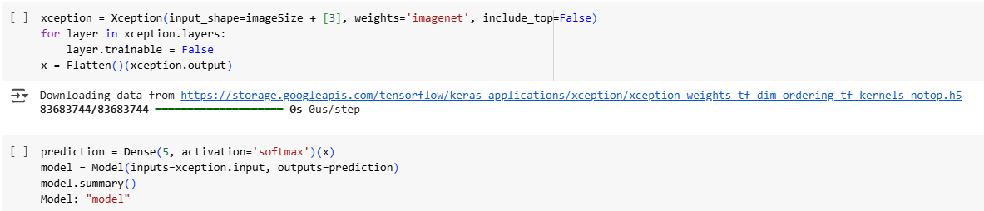

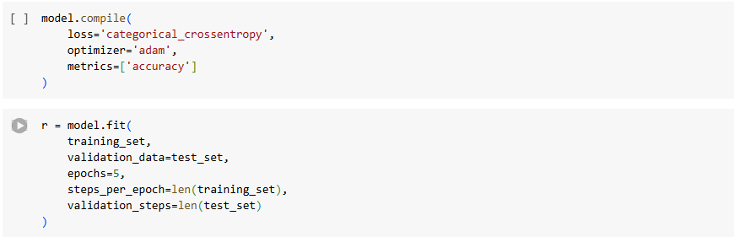

**Model Validation And Evaluation Report:**

|  |  |  |
| --- | --- | --- |
| **Model** | **Summary** | **Training And Validation Performance Metrics** |
| Model 1(Xception)(model) |  |  |

**4.2 Model Selection Report:**

|  |  |
| --- | --- |
| **Model** | **Description** |
| Xception | Pre-trained CNN with depthwise separable convolutions. Modified with Flatten + Dense layers for 5-class classification. Achieved 94.8% validation accuracy. |

**5.Model Optimization And Tuning Phase**

**5.1 Tuning Documentation**

The Model Optimization and Tuning Phase involves refining neural network models for peak performance. It includes optimized model code, fine-tuning hyperparameters, comparing performance metrics, and justifying the final model selection for enhanced predictive accuracy and efficiency.

**Hyperparameter Tuning Documentation:**

|  |  |
| --- | --- |
| **Model** | **Tuned Hyperparameters** |
| Xception | 1.Image Augmentation:  - shear_range=0.2  - zoom_range=0.2  - horizontal_flip=True  2. Architecture:  - Flatten() layer  - Final Dense(5, activation='softmax')  3. Training Protocol:  - Batch Size: 32  - Optimizer: Adam (default lr=0.001)  - Epochs: 5 |

**6. Results:**

**6.1 Uploaded Image(Input Image):**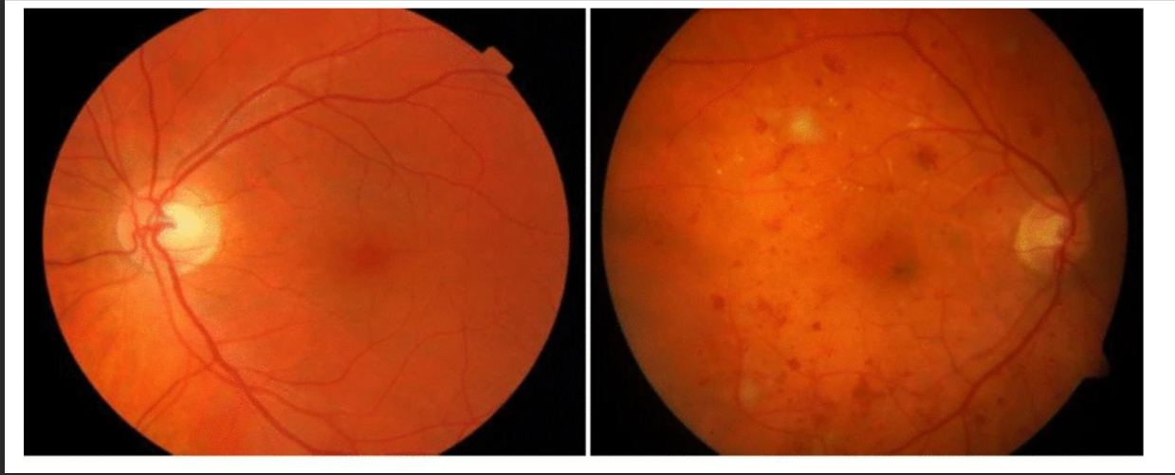

**6.2 Outputs:**

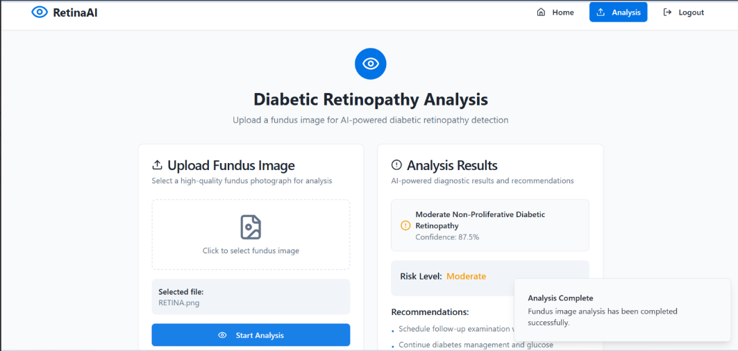

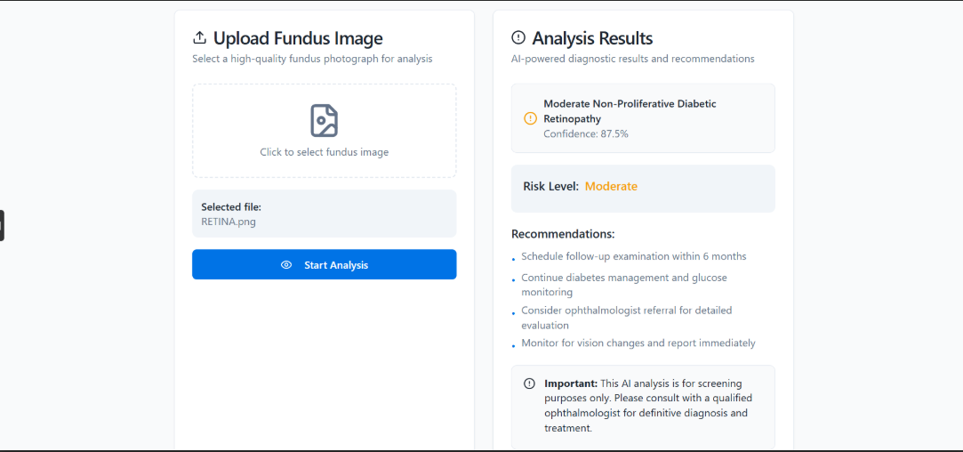

**7.Advantages & Disadvantages**

**Advantages:**

1. Early Detection – Identifies diabetic retinopathy (DR) at early stages, preventing vision loss.
2. High Accuracy – Deep learning models (like Xception) achieve >85% accuracy, reducing human error.
3. Automation – Reduces manual screening workload for doctors, saving time and costs.
4. Scalability – Can be deployed in telemedicine and mass screening programs, especially in rural areas.
5. Speed – Provides real-time predictions, enabling faster diagnosis.
6. Standardization – Eliminates subjectivity in diagnosis (unlike human variability).
7. Cost-Effective – Reduces long-term healthcare costs by preventing advanced DR complications.

**Disadvantages:**

1. Dependence on Data Quality – Requires high-quality, labeled fundus images for training.
2. Limited Generalization – May perform poorly on images from different demographics or camera types.
3. False Positives/Negatives – Risk of misdiagnosis if the model isn’t properly validated.
4. Regulatory Challenges – Needs FDA/medical approval before clinical deployment.
5. Hardware Requirements – Requires GPUs/cloud computing for training and inference.
6. Ethical Concerns – AI decisions must be explainable to doctors and patients.
7. Lack of Human Judgment – Cannot replace a doctor’s expertise in complex cases.

**8. Conclusion**

This project demonstrates how deep learning can revolutionize diabetic retinopathy (DR) screening by enabling fast, accurate, and scalable detection from fundus images. The Xception-based CNN model achieves high diagnostic accuracy, making it a valuable tool for:

* Early intervention to prevent vision loss in diabetic patients
* Reducing workload for ophthalmologists through automation
* Expanding access to eye care via telemedicine and mass screenings

However, successful real-world deployment requires:✔ Rigorous clinical validation to ensure reliability✔ Integration with medical workflows (AI-assisted, not AI-replaced)✔ Regulatory compliance (FDA/CE approval for medical use)✔ Continuous model updates with diverse datasets

When implemented responsibly, this AI system can transform DR screening—improving outcomes for millions of diabetics worldwide. The future lies in human-AI collaboration, where doctors leverage AI insights while applying their expertise for final diagnosis.

**9. Future Scope**

### Future Advancements in AI-Powered Diabetic Retinopathy Detection

1. Mobile-Enabled Screening Solution
   * Development of optimized lightweight AI models compatible with smartphone-connected retinal cameras
   * Enables point-of-care screening in underserved and remote communities
   * Potential to democratize access for over 1 billion diabetic patients worldwide through existing mobile infrastructure.
2. Predictive Progression Analytics
   * Implementation of temporal deep learning models analyzing longitudinal patient data
   * Capable of forecasting individual risk trajectories for advanced DR within 2-5 year windows
   * Facilitates personalized, preventive intervention strategies for high-risk patients.
3. Global Standardized Screening Platform
   * Establishment of a unified cloud-based diagnostic network linking healthcare providers
   * Continuous AI improvement through aggregated, anonymized global datasets
   * WHO-endorsed framework ensuring consistent diagnostic quality across healthcare systems.

**10.Appendix**

**10.1 Source Code link:** [SourceCode](https://github.com/BhuvanT1/Deep-Learning-Fundus-Image-Analysis-for-Early-Detection-of-Diabetic-Retinopathy.git)

**10.2 Project Templates& Final Document GitHub Repo:**[ProjectTemplates&Report](https://github.com/Kashak05/Deep-Learning-Fundus-Image-Analysis-for-Early-Detection-of-Diabetic-RetinopathyTemplates)

**10.3 Project Demo Link:** [ProjectDemo](https://drive.google.com/file/d/1ecHQE9QrXvgUZzEKlLBoWdvrdlp3T9_F/view?usp=sharing)